SIMATS ENGINEERING (SAVEETHA SCHOOL OF ENGINEERING)
Department of Computer Science and Engineering
ASSESSMENT TOOL 3 – FUNCTION CALLING & STRUCTURED OUTPUT TASK
Course Code: | CSA65 | Course Title: | Generative AI and Large Scale Models
CO Assessed: | CO2 – Precision (BL2, BL3) | Assessment: | Assessment Tool 3 – Function Calling & Structured Output Task
Weightage: | 40% of CIA | Total Marks: | 1 * 100 = 100 (1 Question1)
CO2 Statement: | Apply prompt engineering techniques and utilize pre-trained Large Language Models through modern AI frameworks and APIs to solve real-world problems (BL2, BL3)
Student Name: | M. Hemalatha | Reg. No.: | 192472042
Section / Batch: | CSE-AI | Date: | 04-08-2026

Instructions to Students
· Answer 1 question. Total: 100 Marks.
· Analyze the given scenario and identify the appropriate function(s), tool(s), parameters, and structured output required to solve the task.
· Design a valid function-calling schema with appropriate function names, parameters, data types, required fields, and descriptions based on the given requirements.
· Implement the function-calling workflow demonstrating the complete process: User Query → LLM → Function/Tool Call → Function Execution → Structured Response.
· Ensure that the generated output strictly follows the defined structured format or JSON schema and contains valid, relevant, and consistent information.
· Clearly document the designed schema by explaining the purpose of each function, its parameters, data types, required fields, expected input, and expected output.
· Briefly justify the design decisions and explain how function calling and structured output improve the reliability, consistency, and usability of the LLM-based application.
Submission Requirements
Students should submit:
- Source code / Jupyter Notebook
- Function-calling schema
- Structured output/JSON schema
- Execution screenshots
- Test cases and results
- Brief documentation explaining the schema and function-calling workflow

Code of Conduct
I ___192472042____ (Name / Reg No) certify that this submission is my original work and that I have adhered to the guidelines specified for this assessment. I understand that any violation of academic integrity rules will result in disciplinary action.
Signature of the Student: ____M. Hemalatha_____.
Customer Support Ticket System using Function Calling with LLM
Title
AI-Based Customer Support Ticket System Using Function Calling
Introduction
Customer support is an essential service provided by organizations to help customers resolve issues related to products or services. Traditional customer support often involves manual ticket creation and tracking, which can be time-consuming and prone to errors. By integrating Large Language Models (LLMs) with function calling, customer support can be automated efficiently.
In this system, the AI assistant understands the user's request and automatically calls the appropriate function. If a customer reports a new issue, the AI invokes the create_ticket() function to generate a support ticket. If the customer wants to know the progress of an existing complaint, the AI calls the track_ticket() function to retrieve the ticket status.
The create_ticket() function accepts customer details such as name, email, issue type, issue description, and priority level. It generates a unique ticket ID and stores the information in a structured format. The track_ticket() function takes the ticket ID as input and returns the current status, assigned support team, and estimated resolution time.
This approach improves customer satisfaction by reducing response time, minimizing manual work, and ensuring accurate ticket management. Function calling enables the LLM to interact with backend systems securely while providing users with natural conversational responses. The system can be integrated into websites, mobile applications, and chatbots to provide 24/7 customer support.

Python Implementation:
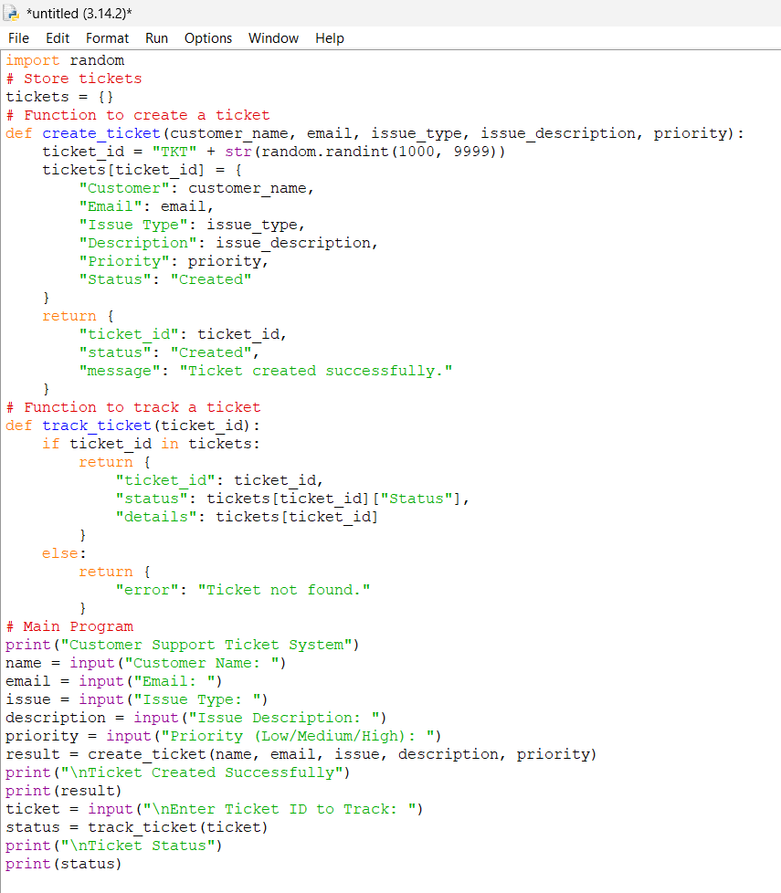
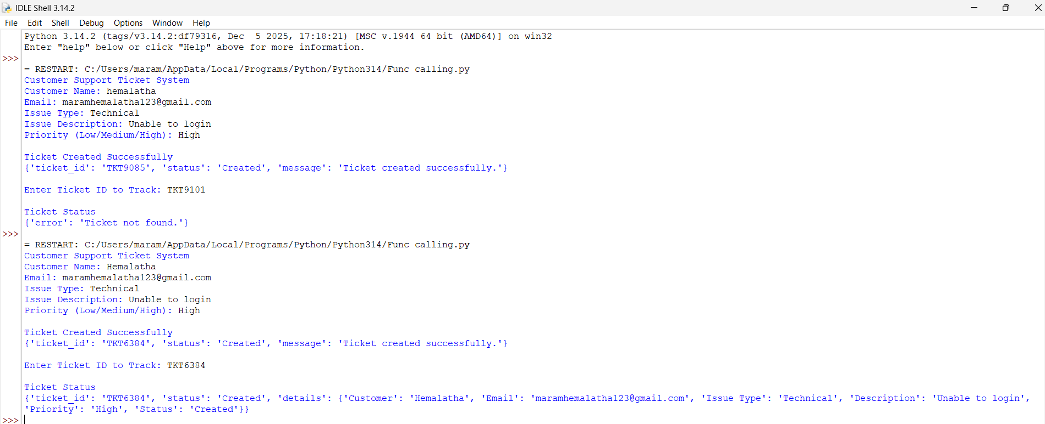
Output:
1. Artificial Intelligence (AI)
- AI enables machines to understand and respond to customer queries.
- It automates repetitive customer support tasks.
2. Large Language Models (LLMs)
- LLMs (such as GPT) understand natural language.
- They identify the user's intent and decide which function to call.
3. Function Calling
- Allows the LLM to interact with external functions or APIs.
- Example:
  - create_ticket() → Creates a new support ticket.
  - track_ticket() → Retrieves the status of an existing ticket.
4. Customer Support Ticket System
- A system that records customer complaints or requests.
- Each request is assigned a unique ticket ID.
- Tickets are tracked until the issue is resolved.
5. Ticket Lifecycle
- Customer submits an issue.
- AI creates a ticket.
- Ticket is assigned to a support team.
- Status is updated (Created → In Progress → Resolved → Closed).
- Customer tracks the ticket using the ticket ID.
6. Structured Data (JSON)
The AI returns responses in JSON format.
Example:
{
"ticket_id": "TKT1001",
"status": "Created",
"priority": "High"
}
7. Required Parameters
- Customer Name
- Email
- Issue Type
- Issue Description
- Priority
- Ticket ID (for tracking)
8. Benefits
- Faster customer support
- 24/7 availability
- Reduced manual effort
- Accurate ticket management
- Improved customer satisfaction
9. Applications
- E-commerce customer support
- Banking help desks
- Healthcare appointment support
- Telecom service centers
- IT help desks
- Educational support portals
10. Technologies Used
- Python
- Functions
- Dictionaries (to store tickets)
- JSON
- LLM (GPT)
- Function Calling
11. Workflow
Customer
│
▼
AI Assistant (LLM)
│
├── create_ticket()
│ │
│ ▼
│ Ticket Database
│
└── track_ticket()
│
▼
Ticket Status
│
▼
Customer
12. Limitations
- Requires a valid ticket ID.
- Depends on an updated database.
- Complex issues may still need human support.

